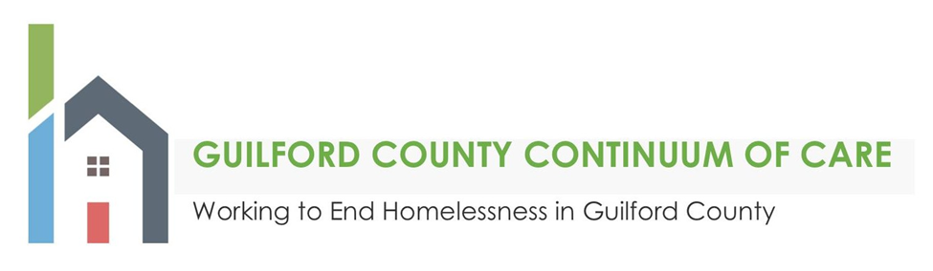

2023 Local NOFO Competition Cover Letter
Date: _______________

Agency Name:

Nature of Project (Renewal Project or New Project):

Project Type:
_____ Permanent Supportive Housing (PSH)
_____ Rapid Rehousing (RRH)
_____ New “Joint Project”
_____ Supportive Services including HMIS and Coordinated Entry

Project Name:

Proposed Funding Amount:

Source and Amount of Match Funding (Including any in-kind contributions):

Name and Contact Information of Agency Contact Person:

Name and Contact Information of the Person Responsible for Preparing the Application in e-snaps:

Will this project utilize the Housing First* approach? ____Yes ____No
*Housing First is an approach to quickly and successfully connect individuals and families experiencing homelessness to permanent housing without preconditions and barriers to entry, such as sobriety, treatment or service participation requirements. Supportive services are offered to maximize housing stability and prevent returns to homelessness as opposed to addressing predetermined treatment goals prior to permanent housing entry.

__________________________________________ (Agency Name) and _________________ (Date), We agree to abide by the Guilford County Continuum of Care Governance Charter and Written Standards, to adhere by attending at least 75% of the CoC membership meetings and actively participating in CoC committees, participating in Coordinated Entry (CE) and the established CE Policies and Procedures, and participating in the Homeless Management Information System(HMIS) if awarded funding.

