Guilford County Animal Services

*Foster Kitten Packet*

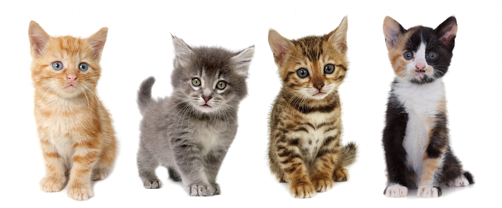

Fostering Saves Lives!

*Table of Contents*

**Welcome and Introduction** …………………………………………………………………………………….……..………………………………………3

**Important Procedures for Foster Parents** …………………………………………………………………………………….……………………….3

**Foster Supplies** ……………………………………………………………………………………………………………..………………….……………………4

**How to Care for a Mother and Kittens** ………………………………………………………………………………..……………….……………….4

Setting Up ………………………………………………………………………..……………………………………….……………………………..4

Neonatal Period: Birth to 2 Weeks……………………………………………………………………………………………………………..5

Transitional Period: 2-4 Weeks of Age……………………………………………………………………………………………………….6

Socializing Period: 4-8 Weeks of Age………………………………………………………………………………………………………….6

Birthing at Home………………………………………………………………………………………………………………………………………..7

Problem Behaviors in Mother Cats……………………………………………………………………………………………………………9

When to Separate Kittens from Moms…………………………………………………………………………………………………….10

Medical Concerns for Mothers and Kittens………………………………………………………………………………………………10

**How to Feed Kittens at Different Ages** ………………………………………………………………………................………………………...12

Orphaned Bottle Babies (Newborn- 4 weeks) …………………………………….…….…………………………………………….12

Feeding Problems…………………………………………………………………………………………………………………………………….13

Newly weaned/Learning to wean kittens (4-5 weeks old) …………………….…………………………..…………………….14

Fully weaned kittens (5 weeks and older) ………………………………………………….….…………………………………………14

**Stimulation** ………………………………………………………………………………………………………………….………….……………………………14**Keeping a Warm Environment** ………………………………………………………….………………………….……….……………………………..14

**Keeping Your Foster Healthy**………………………………………………………………………………………….……….…………………………...15

Upper Respiratory Infections……………………………………………………….…………………….……………………………………15

Ringworm…………………………………………………………………………………………………………….…………………………….……16

Hypoglycemia …………………………………………………………………………………….………………….……………………………….17

Dehydration……………………..………………………………………………………………………………….……………………………….…17

Problems with Dried Food/Stool on Kittens…………………………………………………………….………………………………18

Intestinal Parasites…………. ……………..……………………………………………….……………………….……….……………………18

Panleukopenia ……………………..………………..…………………………………………..…………………….……………………………18

Loose Stool or Diarrhea……………………………………………………………………………………………….………………………….19

Poop Consistency Chart……………………………………………………………………………………………….………………………….19

Other Issues ……………………………………………….…………………………..…………………………………….……………………….20

**Socialization** ……………………………………………………………………………………………………………….……………….……………………….20

**Showcasing Your Foster** ……………………………………………………………………………………………………………….………….…………..21

**Adoption** ……………………………………………………………………………………………………………………….……………….…….………………21

**Important Contacts** …………………………………..…………………………………………………………………………………….…………………..22

**Developmental Milestones** ……………………………………………………………………………………………………………….……….………..23

*Welcome and Introduction*

Welcome to the Guilford County Animal Services Foster Program! Our mission at Guilford County Animal Services (GCAS) is to help our county be a safe, compassionate, and healthy place for people and animals. We work to control the loose animal population, as well as increase the positive outcomes for homeless animals in the county. GCAS is the only open admission shelter in Guilford County. As we expand our life-saving programs, working collaboratively is more crucial than ever, both in the shelter and outside of our front doors.

*Important Procedures for Foster Parents*

**Communication**

**The Foster Coordinator can be reached Tuesday-Saturday from 8 AM to 5 PM.** **Please refrain from messaging me during off hours if possible, unless it is a true emergency AND you cannot get ahold of anyone.** Due to a high volume, we will do our best to get back to you in a timely manner. Texting is the best way to reach the foster coordinator. Please contact the front desk, Vet Tech Phone, or Vet Tech Supervisor on Sundays and Mondays from 8 AM to 5 PM.

**Emergencies**

If an emergency arises after hours, please contact Happy Tails Emergency Veterinary Clinic or Carolina Veterinary Specialists. If you cannot get ahold of staff, and you KNOW it’s an emergency, JUST GO! If you have a concern about a nonurgent issue after hours, please contact the appropriate number at 8 AM the following day. If an emergency should arise during our regular business hours, please call the foster coordinator during designated hours or other designated staff.

**Happy Tails ER Clinic**: (336) 288-2688

2936 Battleground Ave | Greensboro, NC 27408

**Carolina Veterinary Specialists** (336) 632-0605

501 Nicholas Rd | Greensboro, NC 27409

**If you need to go Happy Tails or Carolina Veterinary Specialists, please bring your foster paperwork with you and tell the staff you are a foster caregiver for GCAS.** GCAS will cover all medical expenses if an emergency occurs. Once an animal is taken to an emergency clinic, staff will notify you if the animal is stable after examination and can return home.

*Foster Supplies*

**You will provide:**

* Fresh water
* Warming devices that do not automatically shut off, Snuggle Safe discs recommended (for very young kittens without mom or single kittens)
* Non-plastic food/water bowls that can be easily sanitized
* A separate area to keep the foster kittens away from other pets
* Toys
* Plush bedding that cannot fray, i.e. fleece

**GCAS will provide the following:**

* A cat carrier for transport
* Litter pans that can be easily sanitized
* Litter
* Kitten food (both canned and dry, depending on age)
* Kitten milk replacement (KMR) or kitten formula
* Syringes or bottles for young bottle-feeding kittens
* Veterinary care
* Donated foster supplies as they come in

If you would like to continue fostering, you are welcome to keep any supplies that you use! If you decide to no longer foster, please return any supplies (if they are not disposable or soiled beyond use) that GCAS has provided to you, cleaned and sanitized. We can continue to use those things in our program to help other foster caregivers.

*How to Care for a Mother and Kittens*

Fostering mothers with kittens can be very different from fostering orphaned kittens. The mother will do most of the work for you! Your job as a foster is to provide a calm environment where mom and kittens feel safe and secure. It is **VERY IMPORTANT** that these families are kept in a room of their own without interference from family pets – another animal just sniffing through the door is extremely stressful for a mother who is trying to protect her babies.

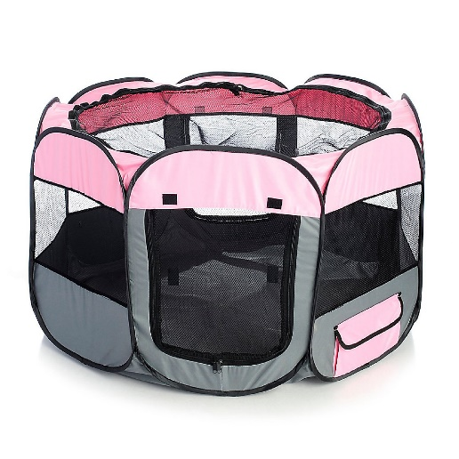**Setting Up**

A large portable, foldable playpen is a great place to house litters with mom. It is best if the playpen has the mesh topping in case you need to confine the mother and litter to the playpen. The bottom of a pen can be lined with a layer of pee pads, then a fleece blanket. Depending on the level of soiling, these may need to be refreshed daily, so it is helpful to have a rotating set of blankets to use. Kittens with mothers should not need a warming device unless the mother is not attentive to them (See *Keeping a Warm Environment* for nest box temperature charts). Mothers who are friendly, and have a small room to themselves, can be allowed to walk in and out of the pen at their leisure. It is normal for mother cats to move their kittens to other areas of a room. If the queen is moving her kittens frequently and you are worried about their safety or it is unmanageable to keep track of them, it may be best to confine the family to the playpen to ensure that all the kittens are being nursed regularly and that the mother cat is not neglecting one or more kittens.

* *Food*

Wet and dry food should **ALWAYS** be available for the mother. She can have as much as she wants, whenever she wants! The kittens will be nursing from the mother until starting the weaning process at 4-5 weeks old. Fresh water should be provided for the mother in an area inaccessible to the kittens until they are at least 4 to 5 weeks old to prevent them from falling into the bowl and drowning.

* *Litterbox*

A litter pan with pelleted litter (either paper or pine) can be placed in the pop-up, or close by if the mother cat can exit the pen. Both litters can be purchased at PetSmart if needed. Place the litter pan opposite the food and water in a pop up, as most cats prefer the two to be as far apart as possible. If they are too close for the mother cat’s liking, it may prevent her from eating and drinking normally. Please do **NOT** use clay litter, and especially any sort of clumping litter. Even though the kittens are not using the box, it is still very messy and can get all over the kittens from the floor and mom. Occasionally, we have had mothers move their kittens into the litter box (another reason clay can be dangerous too!). If this ever happens, please remove them promptly so they do not stay in the soiled area.

 

**Neonatal Period: Birth to 2 Weeks**  
All of their time is spent sleeping and nursing. Newborn kittens should be pink, firm, plump and generally healthy-looking. Normal rectal temperature for newborns is 96-97 degrees Fahrenheit during the first week of life and should gradually increase to 100 degrees Fahrenheit by 2 weeks old. Newborns' eyes begin to open about 7–10 days after birth (sometimes up to 16 days). It takes about two or three days for both eyes to fully open. Even though the eyes are open, the newborn’s sensory system during this time is dominated by stimulation through temperature, touch, and hearing.

* If the eyes fail to open and the lids look sticky, gently wipe the lids with a damp cotton ball to clear any crust. The eyelids should never be pulled apart. If they have not opened by 14 days, contact your veterinarian. Kittens are vulnerable to neonatal ophthalmia during the first 10 to 14 days of life, an eye infection of the conjunctiva. Refer to *Medical Concerns Common in Mothers and Kittens* for more information about this illness.
* When the eyes open the iris is usually a gray-blue color, which gradually changes to normal adult coloring after about five weeks.

A mother’s direct interaction with her kittens includes the “brrp” or chirping calls she makes as she approaches them, as well as nuzzling and licking them to awaken them and to stimulate urination and defecation. Initially, the kitten’s activities are restricted to crawling along the mother’s body and nuzzling against her to locate a nipple, often in competition with litter mates. The kittens suckle, lie still by the mother, move around near her and call out to her.

A call frequently given by the kittens is the cry associated with distress. It is given when a kitten awakens and is hungry, when a kitten’s movement is restricted (e.g., the kitten is trapped under the mother) or he becomes isolated and cold. The mother should answer the call.

Suckling is accompanied by kneading against the mother’s abdomen. It is thought that these kneading movements stimulate the mother’s milk flow, help to develop the kitten’s muscles and aid in digestion. The kittens may initially spend about eight hours a day suckling, but this activity decreases as they grow older.

Please weigh the kittens twice daily in the morning and night at this age. Healthy kittens should be gaining approximately 10g of weight a day.

**Transitional period: 2–4 Weeks of Age**

This marks the beginning of locomotion and sensory development which allows the babies to interact with their environment. Teeth will start to erupt just before 2 weeks of age and will continue until the kitten is about 5 weeks old. The sense of smell is present from birth and will become fully developed by 3 weeks of age. Vision does not play a major role in guiding behavior until about three or four weeks after birth. By the end of the third week, the baby can use visual cues to locate and approach its mother. Visual orientating and following will develop between two and four weeks. Response to depth perception, guided paw-placing and obstacle avoidance all develop somewhat later, between three and five weeks.

**Socializing Period: 4-8 Weeks of Age**

The sensitive period for a kitten to become comfortable with human handling starts at 4 weeks old and begins to close at 7–8 weeks old. It's very important that different people gently handle and play with kittens starting at 4 weeks old. Studies show that just 5–15 minutes of handling per day is enough to aid in socialization at this age.

Social play with mom and littermates becomes prevalent by 4 weeks of age. Playing with objects begins a bit later as the kitten starts to develop the eye-paw coordination — around 7–8 weeks after birth.

Play changes a lot near the end of the weaning period (about seven weeks after birth). Social play becomes more associated with predatory play patterns such as pawing, pouncing, stalking, and biting. Continued positive interactions with people are critical at this stage.

* *Providing stimulation and socialization for kittens*

To help them develop, the environment should be mentally stimulating for kittens. Acquaint the young kittens with different sights, sounds, and textures. Kittens enjoy things like paper bags, wads of crumpled paper, and ping-pong balls. Avoid toys with strings and small pieces as they can be chewed off and swallowed. Make sure all toys are safe, appropriate, and large enough so that the kitten cannot choke on them.

Exposing kittens to a variety of unusual sounds helps them get used to these noises and minimizes fearful, nervous reactions. To help stimulate them, make noises by blowing whistles, clapping hands, jingling bells, or turning on the vacuum cleaner throughout the day. Encourage the kittens to explore, sniff and investigate the noise makers. Praise kittens for positive reactions but do not punish them by forcing them to approach. Do not comfort a kitten that shows fear — it shows them that there is something they should be afraid of.

At around 4 weeks of age, encourage the kittens to be handled individually by different people — men, women, and supervised children of varying ages.

Combine simple play with restraint exercises. This will familiarize kittens to having their paws and ears touched, mouths opened, and muzzles held. Combining this with regular grooming sessions and body massages helps prevent aversion to touch.

Much time and effort is needed to properly socialize kittens between the ages of 4 and 12 weeks old. Daily sessions are very important in shaping the animal’s future personality and emotional growth.

**Birthing at Home**

## *Signs of Impending Labor*

The duration of a cat pregnancy is roughly 65 days, give or take five days.

* ***Nesting:***A day or two before labor, your cat will seek out a quiet and safe place to have her kittens. She may choose a spot you make for her or look to hide out in the back of a closet or under a bed.
* ***Behavioral Changes:***You may notice your cat will begin restless pacing, panting, excessive grooming (especially in the area of her genitals), and excessive vocalization. She will also stop eating.
* ***Physical Changes in Labor:***Your cat's rectal body temperature may drop below 99 degrees Fahrenheit and she may vomit. You might see the abdomen "drop" a few days before labor, and the cat's nipples might get larger, darker, or pinker.
* ***Active Labor Signs:***Contractions—the uterine movements that move the kitten down the birth canal—may make your cat yowl through the pain. You may also see a discharge of blood or other fluids.

During the birth process, rhythmical uterine contractions gradually increase to push the fetus out of the uterus and into the birth canal.

It takes, on average, half a day for a queen to give birth to all her kittens.The first kitten should arrive within an hour of the start of active labor. The birth of one kitten can take anywhere from 5 to 30 minutes. The kittens are born within their amniotic sacs, which the queen will remove. The mother cat will stimulate the kittens to breathe by washing them with her rough tongue. She will also sever the umbilical cord by chewing on it approximately one inch from the kitten's body. She may also eat the placenta. The kittens will immediately gravitate toward a nipple, latch on, and nurse.

If the mother cat ignores the kitten and it is still in its sac, you will need to carefully cut or tear the membrane pouch and stimulate the kitten's breathing by rubbing its nose and mouth gently with a rough, dry towel. If the mother cat has difficulty biting off the umbilical cord, tightly knot dental floss around the umbilical cord 1 inch from the kitten's body and cut the umbilical cord on the mother's side of the tie.

If a placenta does not come out with each of the kittens, make sure it expels within 24 hours after birth. Each kitten should have one placenta. It is a good idea to count the placentas. If the placenta remains in the cat, you will need to see a veterinarian.

About 30 to 60 minutes may pass between births, but more prolonged periods are common If there is a delay of over 4-6 hours and you are sure there are remaining kittens, the queen needs examination by a veterinarian. Whether the birth went smoothly or not, the mother cat and kittens should be [examined by the shelter veterinarian](https://www.thesprucepets.com/when-to-call-the-vet-552168) within 24 hours of birthing.

* *Problems During Labor*

Fortunately, most queens can deliver their kittens without human intervention. However, some complications may occur.

* **Extended contractions without birth:** If your cat is having more than 60 minutes of strong contractions without any progress, take it and any kittens to your vet.
* **Retained placenta:**If your cat does not pass each of the placentas, it can lead to a uterine infection. Count each of the placentas, even if the queen eats it. The number of placentas should equal the number of kittens.
* **Kitten lodged in the birth canal:**Most kittens are born head-first. Breech (tail-first) births occur about 40 percent of the time and are considered normal.A kitten lodged in the birth canal for more than 15 minutes is likely in distress. Call the foster coordinator right away if a kitten is lodged in the birth canal for more than 10 minutes or if you see green discharge without a kitten following within 15 minutes.
* **Stillborn kittens:**It is common for one to two kittens to be born stillborn. Remove the dead kitten from the area so the mother can continue uninterrupted with birthing the other kittens. Please notify the foster coordinator for the proper protocol for disposal.
* **Postpartum hemorrhaging:**Although some bleeding after giving birth is normal, excessive bleeding or hemorrhaging is an emergency and requires immediate veterinarian attention. If ignored, the mother cat can die. If the regular bleeding continues for more than a week after birth or if the bleeding stops for a day and then starts again, please consult with the foster coordinator.

**Problem Behaviors in Mother Cats**

* *Maternal neglect*

Sometimes a mother cat stops providing care to one or all her kittens. The neglect may be because of a birth defect or weakness in the kitten; she may just be trying to follow nature’s course, focusing her attention on the stronger kittens. Neglect may also happen because she is inexperienced or she’s in a stressful environment. Either way, that’s why it’s so important to make daily observations to ensure that she is caring for her babies. If she will let you handle the kittens, you should weigh each kitten once a day to ensure that they are gaining weight. If you notice that she is spending all her time away from the kittens, is not grooming or nursing them frequently, or doesn’t respond to their cries, please call the foster coordinator right away.

* *Maternal aggression toward other animals*

Aggressive behavior directed at other animals is common and expected from mother cats because they always have a maternal instinct to protect their young. With that in mind, please do not try to introduce her to the other animals in your home. As mentioned above, the mom cat and her kittens should have a quiet room of their own away from all other pets so that she and her babies can always feel safe. If she has seen another animal and becomes stressed or aggressive, it is very important to leave her alone and not try to comfort her. Give her 20 minutes or so to calm down and then check on her.

* *Maternal aggression toward people*

Sometimes mother cats will act aggressively toward people. These behaviors may include hissing, growling, swatting and biting. Again, the mother is merely trying to protect her young. We evaluate mom cats for these behaviors before sending them into foster homes, but sometimes the behaviors develop later. If you have a mother exhibiting these behaviors, do not try to “correct” the behavior with a spray bottle or any type of punishment. She is only acting out of instinct to protect her babies and you could cause her aggressive behavior to escalate.

Contact the foster coordinator at the first sign of any of the above behaviors so we can assess the situation and decide on the safest option for momma and her babies.

**When to Separate Kittens from Moms**

If all your foster animals, mom included, are healthy and friendly, we have no reason to separate mom from kittens before they are eight weeks old. But there are a few medical or behavioral reasons for separating them earlier than eight weeks:

* As mentioned above, if the mother cat is showing signs of maternal neglect and is no longer caring for her kittens, the foster coordinator may decide to separate her from her kittens.
* If the mother cat is semi-feral or very under socialized, we may decide to separate the kittens once they are eating on their own consistently and no longer need to nurse (around four to five weeks old). Separating them would prevent the kittens from learning feral behaviors from their mother and help them to become socialized, which increases their chances of finding forever homes.
* If there is a medical concern about the mom or babies, a veterinarian could make the decision to separate the kittens from the mother cat.

The kittens’ best chance at survival is to stay with their mom. Please do not separate your foster kittens from their mom for any reason, or attempt to supplement the mother’s milk with formula, without consulting the foster coordinator.

**Medical Concerns for Mothers and Kittens**

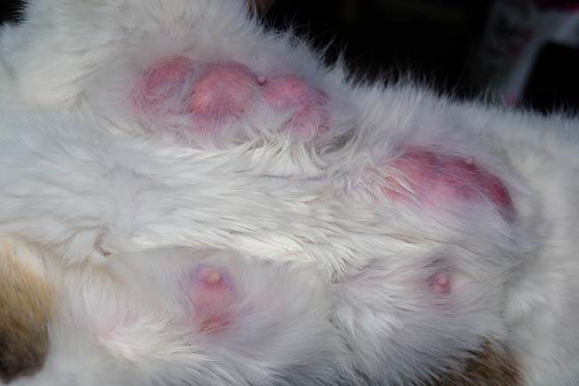

* *Mastitis*

Mastitis, meaning inflammation of the mammary glands, can occur during early lactation or nursing. Mastitis typically affects one mammary gland and results in a firm, hot, painful, and enlarged mammary gland. The cause may be simple congestion of the milk ducts, and application of gentle heat and massage will allow milk to come out of the teat orifice or opening. Gently milking the affected gland can quickly relieve the situation. If the mastitis is due to infection, the gland will be painful, swollen with an abnormally colored discharge from the nipple, and the cat will refuse food, be feverish, and inactive. An abscess can also form, resulting in a purplish area of tissue with thick, foul-smelling discharge. Mastitis due to infection requires immediate veterinary treatment. When mammary gland becomes infected with bacteria, the milk becomes toxic to kittens causing septicemia and/or sudden death. Kittens will need to be supplemented until the mastitis resolves.

* *Hypocalcemia/Eclampsia (Milk Fever)*

​Eclampsia, also called milk fever or lactation tetany, can occur 3-5 weeks after giving birth to kittens. This condition can result from a lack of calcium during [pregnancy](https://www.thesprucepets.com/care-of-a-pregnant-cat-555417) and nursing. Early signs of milk fever include restlessness, panting, muscle tremors, and incoordination. Without treatment, it can progress to tetanic (rigid, stiff-legged) muscular spasms, followed by convulsions (seizures) or coma. This is a life-threatening condition. While the mother recovers, the kittens will need to be fed by hand.

* *Uterine Metritis*

Metritis is a severe infection of the uterus; it is also a veterinary emergency. ﻿ The mother cat will usually have normal vaginal drainage after birthing her kittens. But, if you notice a foul-smelling, deep red-wine or black colored discharge, that is a red flag. Other symptoms include lethargy, fever, inappetence, and loss of [milk production](https://www.thesprucepets.com/queens-milk-supply-552389). The mother cat may have to be hospitalized for treatment and might need an emergency spaying. As the mother cat recovers, feeding and care for the kittens will fall to you. If the queen becomes toxic, the milk will be toxic.

* *Retention of Fetal Membranes*

​Sometimes a queen won’t pass the final set of fetal membranes/tissue after birthing is completed. When this happens, the membranes will begin to break down and rot in her uterus. The queen often becomes restless and experiences discomfort in her belly area and won’t want to nurse, lay with, or take care of her kittens. She may eat very little or refuse food and water, and a brownish vaginal discharge may be evident. If you notice these signs, your cat requires immediate veterinary care.

* *Iron Deficiency Anemia*

While not a common cause in kittens, iron deficiency anemia in newborns can be attributed to an anemic queen whose milk contains a low iron content. Symptoms include: undersized kittens, slow growth, excessive fatigue, and pale mucous membranes.

* *Kitten Septicemia*

Bacteria from contaminated milk can also cause a blood-borne infection called kitten septicemia that is found to occur in kittens typically less than 2 weeks of age. Bacteria from contaminated milk will penetrate the intestinal wall lining and enter the bloodstream. Symptoms will be similar to toxic milk syndrome, and will also include:

* + Straining to defecate
  + Distended abdomen that is tinted dark red or blue, indicating peritonitis
  + Refusal to nurse
  + Continued weakening signs, such as: dehydration, weight loss, chilling
  + Diarrhea
* Many kittens die within their first week of life

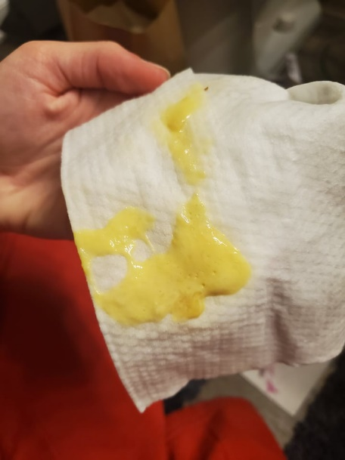

* *Neonatal Diarrhea*

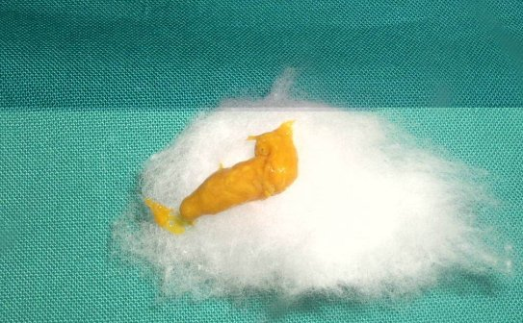

Normal Neonatal Stool Diarrhea

Normal kitten poop should be the consistency of toothpaste/soft serve (like a mini version of adult cat poop!), and pasty and yellow to tan in color. Foamy or watery stools and abnormally colored stools (bloody, bright yellow, green or white) may indicate problems and should be investigated.

*How to Feed Kittens at Different Ages*

Always wash your hands before and after handling the kittens! Make sure that food/water bowels are cleaned daily.

We ask that you weigh your kitten(s) each day at the same time to keep track of any gains or losses. Ideally, kittens should gain 0.25–0.5oz per day. If your kitten is not eating for 24 hours or is losing weight, please contact our foster team immediately.

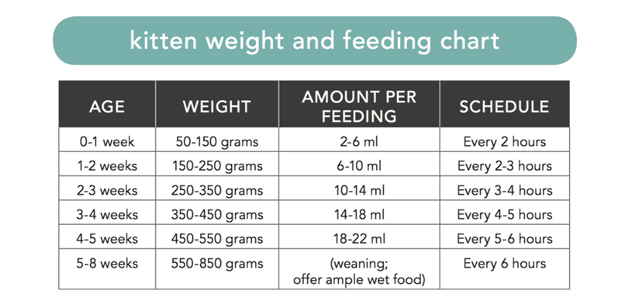

Source: Kittenlady.org

**Orphaned Bottle Babies (Newborn- 4 weeks)**

Clean the bottles by washing in warm soapy water and rinsing in hot water. Prepare formula as directed on package. Cut a small hole in the nipple. When turned upside down, the formula should barely drip out of the nipple. KMR formula is made with 1-part powdered formula to 2-parts water. Refer to “Kitten Weight and Feeding Chart” for approximate feeding amounts. Warm the formula to approximately 100 degrees F. The formula should feel warm on your wrist at this temperature. It is acceptable if individual kittens vary slightly from the recommended feeding amounts. Make sure the kitten is lying on its stomach in a natural position to feed. **Do not hold kittens on their backs like human babies or squeeze the bottle while feeding—this can cause kittens to aspirate the milk, choke and/or catch pneumonia.** You may have to give the kitten a couple of minutes to get used to the nipple or syringe. Hold the bottle at a 45-degree angle to prevent air from entering the kitten’s stomach. If you see formula come out of the kitten’s nose, stop feeding immediately and let the kitten clear the formula. If you hear crackling sounds when the kitten breathes, or believe it may have aspirated formula, contact the foster coordinator immediately. *Always burp the kitten after each feeding.* **Do not feed milk not specified for kittens, nor overfeed. This will cause medical issues!**

**Feeding Problems**

There are two common feeding mistakes that can cause health problems for a kitten, overfeeding and underfeeding.

* *Overfeeding*

Overfeeding a newborn kitten can cause serious health complications. The kitten’s immature kidneys have a very limited capacity and are unable to handle excessive amounts of fluid. Overloading the digestive system causes diarrhea. Diarrhea causes dehydration which can kill a kitten if it is not corrected.

The kitten’s stool should be firm a yellowish in color. A loose yellowish stool is a sign of mild overfeeding. Greenish stool indicates food is passing too rapidly through the kitten’s system. Grayish stool with a foul odor indicates inadequate digestion of formula and it is the most serious form of diarrhea.

* *Underfeeding*

Underfeeding is life threatening to the newborn. A kitten that is underfed is restless and cries excessively. It will eventually appear listless and apathetic.

A kitten that is underfed will eventually become dehydrated and chilled. If this has happened, you will have to warm and rehydrate the kitten if it is to survive. To be sure you are feeding the correct amount of formula refer to the kitten’s weight chart on page 10. **Keeping accurate records of the kitten’s weight is extremely important.** Having weighed the kitten initially you will be able to tell if the kitten has gained weight steadily during the first seven days.

**Newly weaned/Learning to wean kittens (4-5 weeks old)**

When first starting to wean kittens, add canned kitten food to the bottle formula and blend well to prevent clogging the nipple. If they are not yet interested in whole canned food on a plate, they should be offered “kitten slurry”. This consists of warm water, kitten milk replacement, and canned kitten food that is stirred into a soup consistency. You can adjust the ingredients as needed to make sure they are eating. If they are not eating entire meals of the slurry, supplementing with the bottle is necessary to ensure the kittens are eating full meals. Once the kittens have teeth, care should be taken to ensure they do not bite or chew on nipple. Swallowing any small piece is a choking hazard and could put them at risk for intestinal blockage. Kittens that have just been weaned will need to be offered fresh canned kitten food 2-3 times a day. They will be very messy eaters so please keep them clean by wiping them with a warm wet cloth. Fresh water should always be available.

**Fully weaned kittens (5 weeks and older)**

At 5 weeks old they should be offered dry kitten food with the canned food. You can help their interest in this by mixing some canned with dry, then slowly decrease the amount of canned food you add. Fresh water should always be available.

*Stimulation*

A newborn kitten cannot evacuate its bowel or bladder on its own. After feeding, gently massage and stimulate the ano-genital area with a sterile cotton ball, wipe, or clean cloth dipped in warm water. **You will need to do this after every feeding until the kitten begins to use the litter box.** They should defecate at least once per day and urinate each time. (Refer to General Health Care page)

They should be able to start using a litter box at about 4 weeks old. You may need to start off with a shallow pan if a regular litter box is too high for them to climb in and out of. Use Yesterday’s News or pelleted pine litter.

*Keeping a Warm Environment*

The area where you keep the kittens should be warm, dry, and clean with fresh blankets. A warming device should ALWAYS be on the lowest setting. Anything higher may overheat the kittens or severely burn them. Wrap both the electrical cord (if applicable) and warming device with a towel. They should NEVER be placed directly on a warming device as this could cause severe burns. Check to see if your warming device automatically shuts off or stays on 24/7. Please exercise extreme caution when using a device that does not shut off. If it does shut off, you must be vigilant in rewarming the device on a consistent schedule. We recommend microwaveable SnuggleSafe discs as a safe option. Follow the warming instructions on the disc packaging. The kittens should have room to move off the warming device if they become too hot. The first 2 weeks are especially critical to keeping the kittens warm. Kittens with mothers should not need a warming device unless the mother is not attentive to them.

* *Nestbox Temperature*
  + - Newborn-1 week old- 85-90 F
    - 1-2 weeks old- 80-85 F
    - 2-3 weeks old-75-80 F
    - 3 weeks and older- 70-75 F

*Keeping Your Foster Healthy*

Clean the room/area thoroughly every 5-7 days or as needed**. Phenol-based products are known to be toxic to cats and should not be used. If unsure about a product, a good rule of thumb is to avoid if the name contains “sol”.** Wash litter boxes, clean walls and floors near the litter boxes, and wash all bedding and toys with bleach. **Wear gloves and wash your hands to prevent spread of disease!**

Symptoms of an emergency may include:

* + Fever (102.5 or above, rectally)
  + Respiratory distress (choking, wheezing, open mouth breathing, shortness of breath)
  + Green secretions and/or bad odor from nasal area
  + Not eating or drinking for more than one day
  + Extreme lethargy
  + Continual vomiting or occasional vomiting that lasts more than a day
  + Obvious distress, and/or pain or pronounced behavior changes

For kittens less than 2-3 weeks, open mouth breathing, not nursing or taking the bottle, and crawling away from the litter/mother are often signs of something more serious going on.

Call the animal shelter or foster coordinator if you see:

**Upper Respiratory Infections**

Sneezing, congestion, nasal and/or eye discharge are common signs of URIs in cats. Often, cats with URIs will have a harder time smelling food. Tempting your foster cat with smelly canned cat food, Hills a/d food (can be requested from GCAS), or Gerber baby food (chicken or other meat protein ONLY) can encourage them to start eating. You can also warm the food in the microwave for 5-10 seconds to help “bring out” the smell of the food. Make sure the food is evenly heated and not too hot before giving to the kitten to prevent your kitten from getting burned. You may have to coax them to eat by using your fingers, and even smearing it on their lips or nose. If your foster cat is refusing food, call the foster coordinator to schedule an appointment. Steam from a humidifier or hot shower often helps clear the nasal passages. Keep the nose and eyes clear of discharge with warm, damp cotton balls.

**Ringworm**

Contrary to its name, Ringworm is not a worm at all but a fungus – a lot like “Athlete’s Foot.” In fact, most ringworm is the exact same fungus as “Athlete’s Foot.” When this fungus grows anywhere other than the bottom of the foot, it is called ringworm. The fungi live on the surface of the skin and in the hair follicles.

* *Appearance*

The usual symptom is a round hairless lesion. However, the characteristic "ring" that we see on humans doesn't always appear as a ring on animals. This lesion will grow and often become irregular in shape. Ringworm is commonly found on the face, ears, tail and paws. The lesions are scaly, and the skin may be reddened. The spots may or may not be itchy. 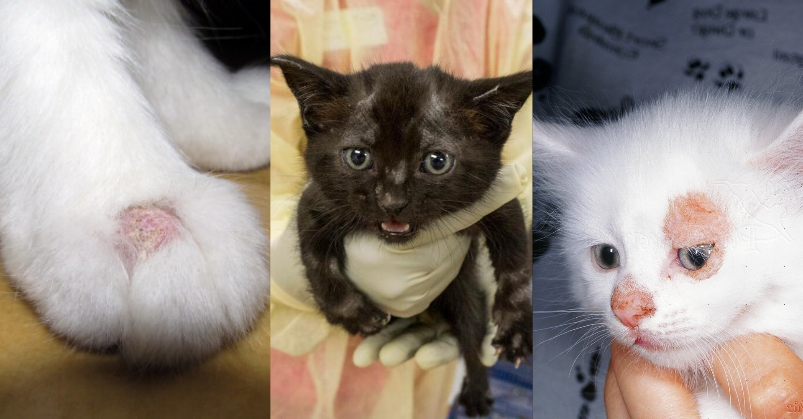

* *Transmission*

Transmission can happen by direct contact with another infected animal or person. It can be passed from cats to dogs and vice versa and from pets to humans and from humans to pets. A ringworm infection in a person typically occurs after a person has pet an infected or carrier cat, but it can also occur after simply handling items that were used by an infected cat.

* *Can Humans Catch Ringworm from Animals?*

Yes, humans can contract ringworm by handling an animal with the condition or sharing a living area with them. Immunocompromised individuals, such as the elderly and very young, are more prone to contracting ringworm.

* *Ringworm Diagnosis and Treatment*

If you see ANY hair loss on your foster animal, please immediately inform the Foster Coordinator. Depending on the photos, they might instruct you to bring your foster pet in for a vet examination. If your pet is found to have ringworm, you will have the option to continue treatment in your home or leave your foster pets at the shelter. The Foster Coordinator will give you more information on treatment options for your foster should you decide to continue.

If your foster is diagnosed with Ringworm, you will need to decontaminate the environment. Use bleach mixed at 1:10 (of 5.25% - 6.15% household bleach) on any surface that you can at least every other day. This solution should kill 80% of the spores. Vacuum daily and dispose of vacuum bags / empty the vacuum canister, which will contain the spores. Steam cleaning of carpets and furnishings will also kill many of the spores – this is best done after the pets have left the home. Don't forget the animal’s bedding! Wash all bedding in hot water with detergent that contains color safe bleach and dry on high for 60 minutes. (Bleach note: Different bleach brands have different % solution. Be sure your bleach is 5.25% - 6.15% solution)

**Hypoglycemia**

A kitten with hypoglycemia (low blood sugar) will lack energy. Kittens need glucose to function normally, as it is the fuel the body burns for energy. Common signs of hypoglycemia include sluggish behavior and/or no interest in moving or eating and lethargy. In severe instances, kittens may have seizures, since glucose is necessary for the brain tissue and muscles to function. These hypoglycemic episodes will cause kittens to fall over and appear weak or comatose. Hypoglycemia is an emergency; therefore, you will need to contact the foster coordinator and bring them to see a vet immediately or take them to an emergency vet if it’s after hours. You may rub Karo Syrup on their gums or honey while you are on the way to see a vet to boost their glucose level.

**Dehydration**

Watch carefully to see if your foster cat is drinking water. You may have to monitor the level of the water bowl and keep track of litter box activity. To check for dehydration, pull the skin up over the shoulder blades. If it slides back quickly, the cat is not dehydrated. If the skin goes down slowly, or does not lie flat again, then the cat is dehydrated and needs fluids. You can also examine the cat’s gums. If they are dry and tacky (instead of moist) this could indicate dehydration. Call the foster coordinator immediately if you suspect your foster is dehydrated.

**Problems with Dried Food/Stool on Kittens**

Keeping your kitten clean and free of dried on food and stool is extremely important to maintaining their health and wellbeing. During the weaning process, kittens may struggle eating wet food and cover themselves around the face, paws and chest with wet food. You must wipe down kittens after each feeding if this is an issue, as the wet food can become cemented onto the fur if left to dry for too long. If this happens, the skin under those areas will become raw and open to infection. This can also cause hair loss. Bathing a kitten after every feeding is not ideal either, as the constant presence of moisture can create an environment for skin infections to brew. To avoid this, it may be helpful to syringe feed the kitten until it learns how to eat without getting itself messy. The foster coordinator will advise you during this process.

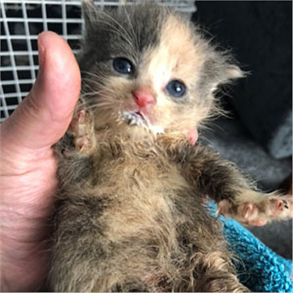

Stool can become stuck in the fur of kittens around the anus and back legs, especially with longhaired kittens and kittens with loose stool or diarrhea. If left to dry, it can also become cemented into the fur, causing the skin underneath to become raw and open to infection. If the stool is left to dry around the anus, it can block the kitten from having bowel movements. This is a medical emergency and can be life-threatening!

Please advise the foster coordinator if you are having these issues as soon as possible.

**FAILURE TO KEEP YOUR KITTENS CLEAN WILL RESULT IN TERMINATION FROM THE FOSTER PROGRAM.**

**Intestinal Parasites**

Kittens need to be dewormed starting at 2 weeks of age and repeated every 2 weeks until able to take monthly preventative. This will be scheduled through the shelter. After worming, it is normal to see worms pass in the stool. If you see white, rice-like segments, please notify the foster coordinator, as they most likely have tapeworms and will need a different type of dewormer. For more information regarding parasites, visit <https://capcvet.org/guidelines/> .

**Panleukopenia**

This is a very contagious and potentially fatal disease caused by the feline parvovirus. The feline parvovirus infects and kills cells that are rapidly growing and dividing, such as those in the bone marrow, intestines, and the developing fetus. Symptoms to look for are lethargy, loss of appetite, vomiting, diarrhea and/or blood in the stool. If you see any of these symptoms call us immediately. See stool consistency chart on next page.

**Loose Stool or Diarrhea**

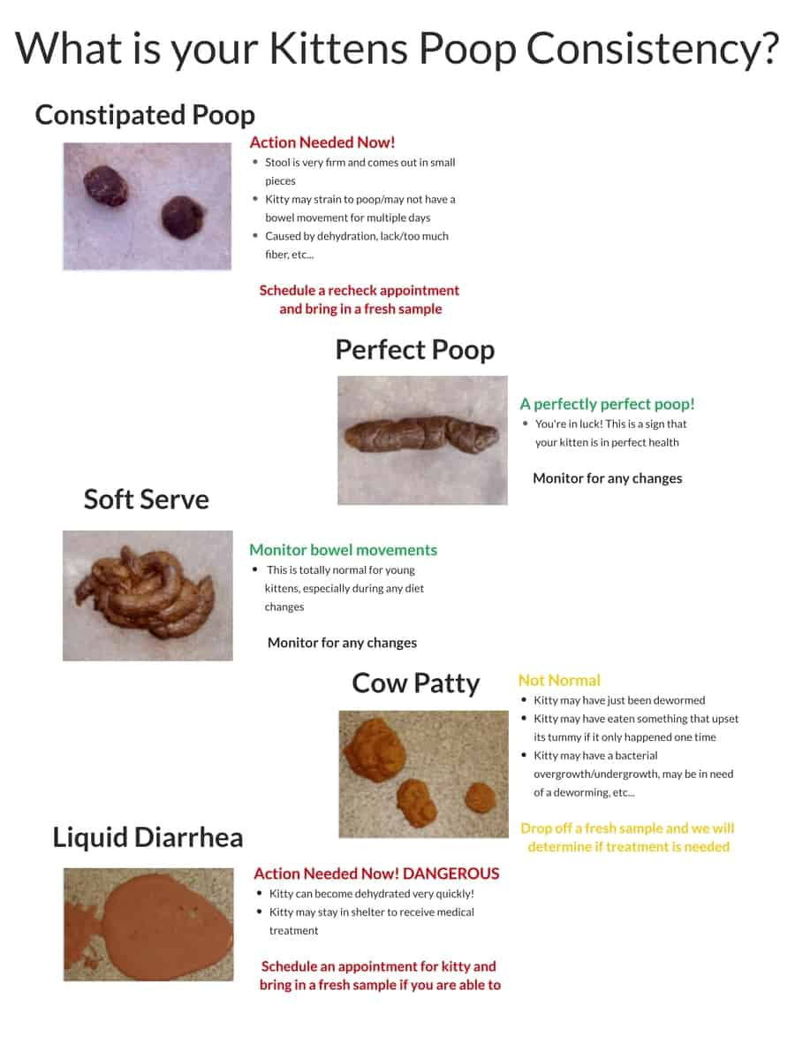Loose stool can have a multitude of causes, including parasites, bacteria, diet changes, and stress. Contact the foster coordinator if your kittens are having loose stool or diarrhea, as your kittens need to be seen as soon as possible. Monitor your kitten’s appetite and hydration levels until it can be seen by the medical staff. Please note if the stool is bloody, has excessive mucus, or a pink tinge. See chart below for help differentiating stool consistencies. (**Courtesy of Maui Humane Society**).

**Other issues:**

* Eyes that are red and inflamed or have an extreme amount of discharge and swelling, vs. small amounts of discharge, usually in both eyes (common with a URI). This can often be treated with eye ointment picked up at the shelter.
* Any crumbly wax-like substance in the ears (possible ear mites). Ear mite medicine can be picked up at the shelter.
* Fleas or flea dirt (black pepper-like substance in the fur). Notify the foster coordinator ASAP if you see live fleas on your foster kittens. Flea infestations can cause life-threatening anemia in young kittens very quickly. You may bathe kittens with Dawn dish soap and warm water. Fleas may migrate to the head of the kitten while bathing to avoid the soap. Please check thoroughly around the eyes, ears, and chin to make sure you don’t miss these. **DO NOT USE A FLEA SHAMPOO OR OTHER FLEA PRODUCT.**
* Failure to thrive: Sometimes kittens that are very young will take a turn for the worse and die quickly with no warning. If you have a foster that dies, please call us and we will have you bring that kitten in to be examined by the medical team to determine if there is a risk to your other kittens.
* Allergies: Cats can have allergic reactions to medications. If a sudden, adverse reaction happens after giving a new medication, such as wheezing or eyes being more inflamed, stop the medication and call the foster coordinator.

*Socialization*

The best time to socialize kittens is between 2-7 weeks of age. During this time, it is crucial that they are exposed to as many positive situations as possible. Raising littermates together will help them learn polite cat behaviors, gain a social identity, and will help them tolerate future feline companions. Invite friends and family over to play and handle them. This will introduce new people and smells to their environment. Get them used to different sounds, such as the doorbell, vacuum, tv, pots, pans, and alarms. **Please DO NOT take your foster outdoors- no exceptions!**Please note that negative experiences during this time can have a lasting lifelong impact on the kittens as well, such as poor interactions with other animals, screaming children, or being mishandled.

A great way to communicate with cats is by “slow blinking” to them. Crease your eyes in the same way you do when smiling, then blink once slowly over period of 3 seconds. If the cat squints or blinks back, they trust you!

* *Tips for An Under-socialized, Fearful Kitten*

Socialization after 2 to 7 weeks old is still possible but is increasingly difficult, especially after 12 to 14 weeks old. Avoid making prolonged eye contact with a fearful kitten. When fearful or stimulated, a cat’s eye will dilate. Keep the kitten in a room with a few places they can hide where you can easily get to if needed. Make frequent visits to the room and sit with them to help them get used to your presence. You may also want to try using a stick or dowel with feathers attached to one end, to provide visual stimulation and distraction. A second stick or dowel with a soft fabric on it can be used to lightly touch and pet the kitten. As the kitten gets comfortable with your presence, try moving closer each time. Do this when the kitten eats, progressing to being able to hand feed and later to touching kitten. At this point, when you can touch them, use a finger to make small 1¼-inch clockwise circles all around kitty’s shoulders, head and upper back. Make the circles small and quick and leave the body after each time. Practicing the slow blink with fearful kittens can also help develop trust and a bond.

*Showcasing Your Foster*

A “Foster Biography” for each animal is a great way to help potential adopters learn about their likes, dislikes, and personality! Send the foster coordinator cute photos that highlight their appearance and personality as well. If the cat has some bad habits, this can be discussed over the phone with any potential adopters. The web story should generate interest, not turn people away. We don’t want to mislead people; however, we really try to focus on the positive. Please email the story to the foster coordinator!

*Adoptions*

Kittens ***MUST*** be 8 weeks or older and weigh at least 2 pounds (so they can be spayed or neutered) to be qualified for the adoption floor. When your foster is ready for adoption, friends, co-workers and relatives may want to adopt. We encourage you find potential adopters for your foster and notify the foster coordinator when you do. Generally, foster families will be the first to be eligible to adopt any foster animal. If you want to adopt your foster this must be made clear to the foster coordinator before the animal is marketed to others for adoption.

We may also have you contact and set up meet and greets with potential adopters that contact us directly about your foster. If they decide to adopt, you can schedule a time to meet here, where they can fill out the paperwork, pay the fees, and adopt the animal. They must have the animal ID number in order to complete the adoption. If you are unsure of the animal ID, contact the foster coordinator.If there are no potential adopters, fosters need to come back to the shelter for our adoption floor when they are 8 weeks old. Please contact the foster coordinator to set up an appointment to bring them back.

*Important Contacts*

**Guilford County Animal Resource Center**

(336) 641-3400

980 Guilford College Rd

Greensboro, NC 27409

**Foster Coordinator**

Kendelle Federico

Available Tues-Sat 8-5PM

(336) 266-4138 *(Texting is the best way to reach me)*

[kfederico@guilfordcountync.gov](mailto:kfederico@guilfordcountync.gov)

**Vet Tech Phone**

336-279-4944

Contact first on Sundays/Mondays for medical concerns

**Katie Bivona, Vet Tech Supervisor**

336-803-2710

Contact second on Sundays/Mondays for medical concerns

**After-Hour Emergency Contacts:**

**Happy Tails Emergency Veterinary Clinic**

(336) 288-2688

2936 Battleground Ave

Greensboro, NC 27408

**Carolina Veterinary Specialists**

(336) 632-0605

501 Nicholas Rd

Greensboro, NC 27409

**For Animal Control emergencies, questions or comments, call (336) 641-5990.**

If you need to return your foster pet due to an emergency that is after-hours, you may first attempt to contact the foster coordinator. If you are unable to reach the foster coordinator and the situation is urgent, please contact Animal Control Dispatch (336-641-5990). If Dispatch is unavailable, you can try calling Metro 911 non-emergency number (336-373-2222). For true emergencies, call 911.

